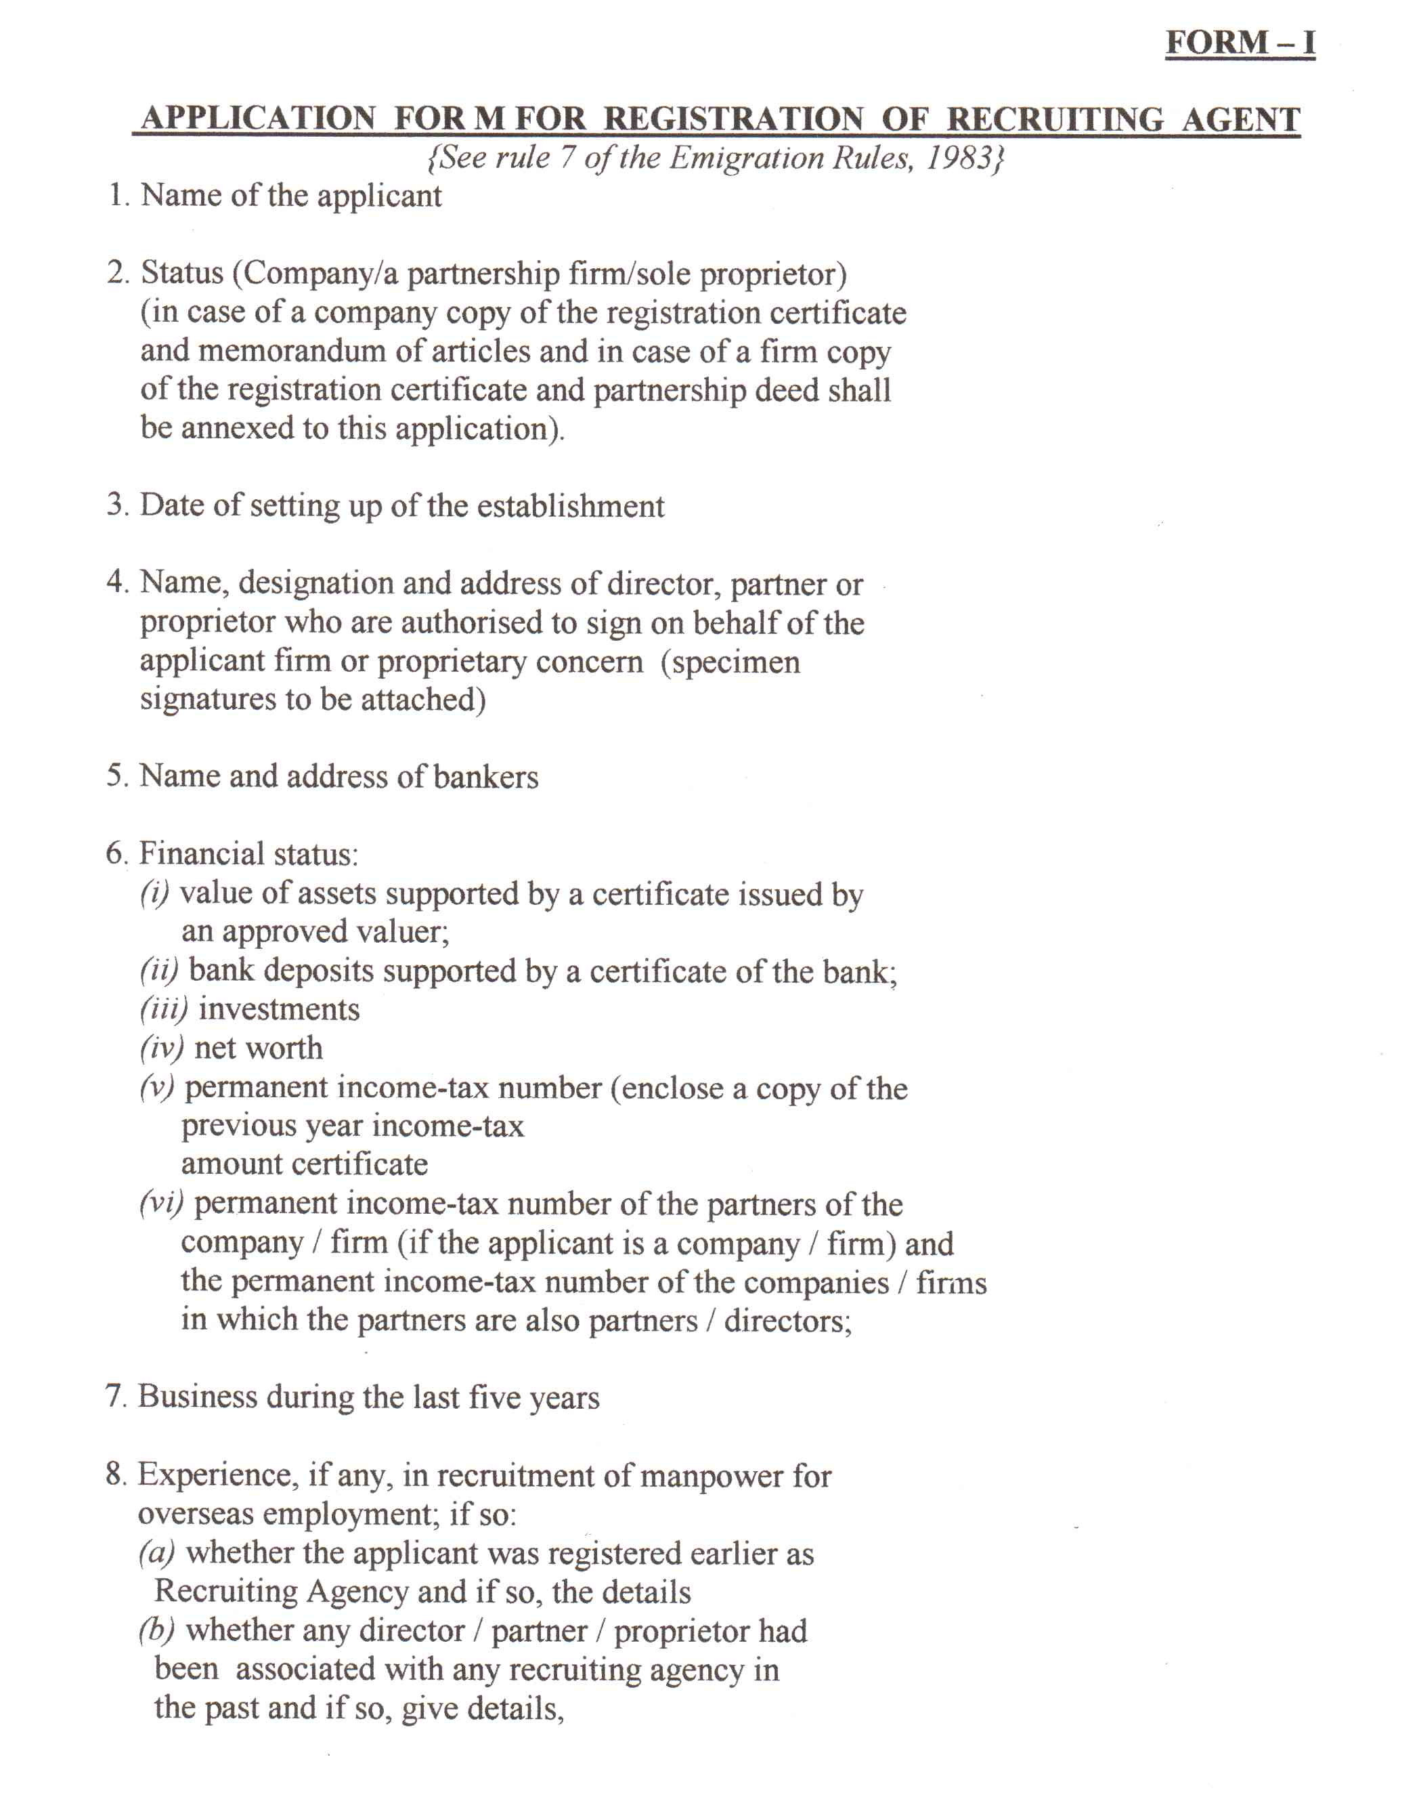
9. If previously in the business of recruitment, total number of workers deployed abroad, year-wise, country-wise and category-wise during the last five years

1O.Whether there are any complaints against the applicant in respect of the workers recruited, if so, details
thereof

11.Whether there is any criminal or civil case pending in any Court against the applicant, if so, details thereof

12.Whether any director I partner I proprietor has ever been convicted; if so, details thereof

13.Whether any certificate issued under the Emigration Act,
1983, was cancelled; ifso, reasons thereof

14.Address of the office premises for conducting business

15.Whether the office premises is owned, on hire or on lease, if the office is in hired I leased premises, the name and address of the owner

I6.Whether business premises are adequate and easily accessible for the public

I7.Give details of the facilities for conducting business at the applicant's disposal

I8.Name of countries where the applicant proposes to concentrate his efforts to deploy Indian workers. How does he remain in contact with these markets

19.Number of workers proposed to be recruited and form in which security is to be deposited

20.Period for which registration is applied for

UNDERTAKING
I undertake that in the event of any of the information furnished above being found to
be false or incorrect in any respect, the certificate is liable to be cancelled

Date

Applicant

